MEETING/FUNCTION ROOM 469 Hillside Road, South Dunedin
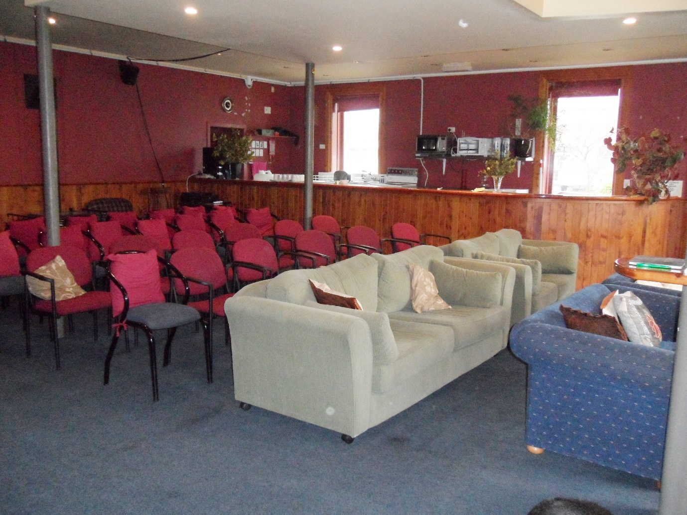

Warm, comfortable room available
Ideal for meetings, workshops, presentations, social functions
Suitable for groups of up to 40 people
Well equipped kitchen
Audio visual equipment available
Hire costs: 1-2 hours $40; half day $80; Full day $150; Weekend negotiable. Bond of $100 for cleaning and use of audio-visual equipment.
For more information or inspection please contact:
Peter on 0220 414 423 or email theosophy.dn@actrix.co.nz

